**Name-Ayan Sadhukhan**

**Regd No-19BEC1448**

**Question –Selection Sort**

**Code-**

#include<stdio.h>

int main()

{

int arr[20],n,temp=0;

printf("Enter the number of elements to be stored in the arrya");

scanf("%d",&n);

for (int i =0;i<n;i++)

{

printf("Enter the %dth element ",(i+1));

scanf("%d",&arr[i]);

}

for (int i=0;i<n;i++)

{

for(int j=i+1;j<=n;j++)

{

if(arr[i]>arr[j])

{

temp=arr[i];

arr[i]=arr[j];

arr[j]=temp;

}

}

}

printf("The sorted array is ");

for(int i=0;i<n;i++)

{

printf("%d ",arr[i]);

}

return 0;

}

**Output-**

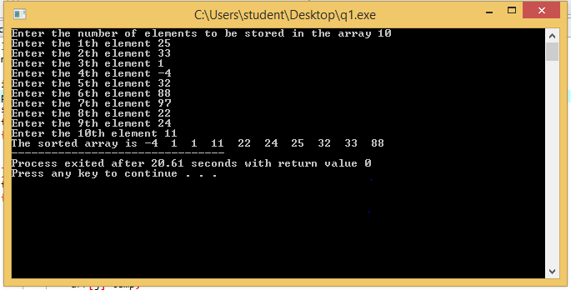

**Question 2- Design an algorithm for the following closest pair problem. Given n points x1,x2,x3,…xn on the real line , find the pair of points which are closest (in the sense of distance) of all such pairs. Implement your algorithm in C programming language. Distance is calculated as the absolute difference between pair of points.**

**Code-**

#include<stdio.h>

#include<math.h>

int main()

{

int a[20],n,temp=0;

printf("Enter the number of elements to be stored in the array ");

scanf("%d",&n);

for (int i =0;i<n;i++)

{

scanf("%d",&a[i]);

}

for(int i=0;i<n;i++)

{

printf("%d ",a[i]);

}

for (int i=0;i<n;i++)

{

for(int j=i+1;j<n;j++)

{

if(a[i]>a[j])

{

temp=a[j];

a[j]=a[i];

a[i]=temp;

}

}

}

int min,b=a[0],c=a[1],max=0;

min=a[0]-a[1];

printf("The sorted array is ");

for(int i=0;i<n;i++)

{

printf("%d ",a[i]);

}

for(int i=1;i<n;i++)

{

max=a[i]-a[i+1];

if(abs(max)<abs(min))

{

min=max;

b=a[i];

c=a[i+1];

}

}

printf("The numbers are %d and %d ",b,c);

return 0;

}

**Output-**

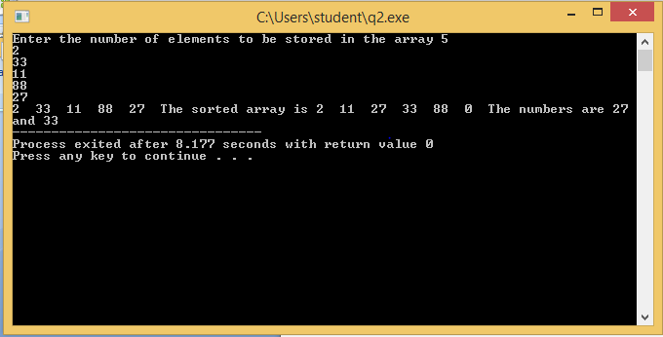

**Question 3- Assume that a square matrix is called a matrix sorted array, only if all the entries are in an increasing order both row and column wise. The below matrix is an example of the matrix sorted array. Design an efficient algorithm to convert the given square matrix into a matrix sorted array. Implement your algorithm in C programming language.**

**Code-**

#include<stdio.h>

int main()

{

int a[20][20],b[20],n,temp=0;

printf("Enter the number of element so be inputted in the array ");

scanf("%d",&n);

for(int i=0;i<n;i++)

{

for(int j=0;j<n;j++)

{

scanf("%d",&a[i][j]);

}

}

printf("The DDA is \n");

int c=0;

for(int i=0;i<n;i++)

{

for(int j=0;j<n;j++)

{

printf("%d ",a[i][j]);

b[c]=a[i][j];

c++;

}

printf("\n");

}

for (int i=0;i<c;i++)

{

for(int j=i+1;j<c;j++)

{

if(b[i]>b[j])

{

temp=b[i];

b[i]=b[j];

b[j]=temp;

}

}

}

int d[20][20],k=0;

for(int i=0;i<n;i++)

{

for(int j=0;j<n;j++)

{

d[i][j]=b[k];

k++;

}

}

printf("The matrix sorted array is \n");

for(int i=0;i<n;i++)

{

for(int j=0;j<n;j++)

{

printf("%d ",d[i][j]);

}

printf("\n");

}

}

**Output-**

